**DATA HANDLING USING ‘Pandas’ and DATA VISUALIZATION USING ‘Seaborn’**

Using the pandas function read_csv(), read  the given ‘iris’ data set.

1. Use appropriate functions in pandas to display
2. Shape of the data set
3. First 5 and last five rows of data set(head and tail)
4. Size of dataset
5. No:of samples available for each variety
6. Description of the data set( use describe

**code**

import numpy as np

import matplotlib.pyplot as plt

import seaborn as sns

import pandas as pd

col=['sepal_length','sepal_width','petal_length','petal_width','variety']

iris=pd.read_csv("iris.csv",names=col)

print(col)

#shape 1

print(iris.shape)

#2

print(iris.head())

print(iris.tail())

#3

print("size",iris.size)

#4

print(iris["variety"].value_counts())

#5

print(iris.describe())

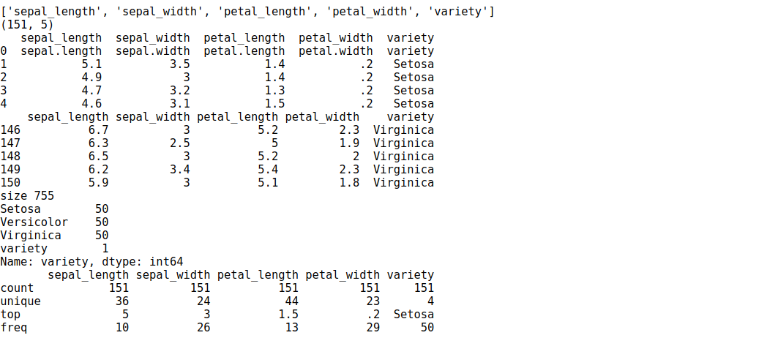

**2. Use  pairplot() function to display pairwise relationships between attributes. Try different kind of plots  {‘*scatter’, ‘kde’, ‘hist’, ‘reg’}* and different kind of markers**

**code**

ir = sns.load_dataset('iris')

g = pd.DataFrame(ir)

g1=sns.pairplot(g,kind="hist", hue="species",height=3)

g1=sns.pairplot(g,kind="kde" , hue="species", vars=["sepal_length","petal_length"])

g1=sns.pairplot(g,kind="scatter" ,hue="species",markers=["o","s","D"])

g1=sns.pairplot(g,kind="reg" ,hue="species")

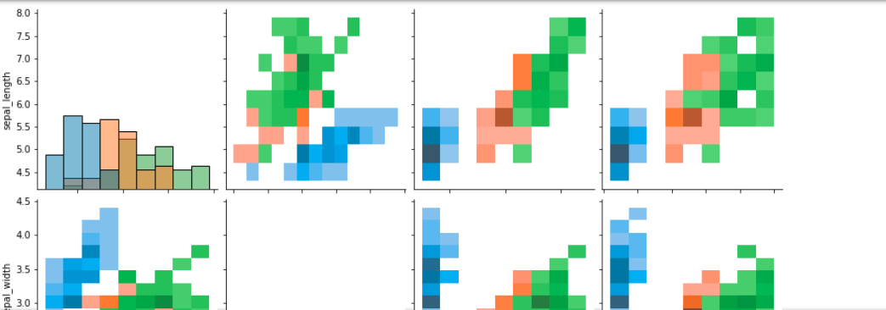

#### **3.using the iris data set,get familiarize with functions:**

**1)displot()**

**2) histplot()**

**3) relplot()**

**code**

sns**.**relplot(data**=**ir)

sns**.**displot(data**=**ir)

sns**.**histplot(data**=**ir,)

